**Sprint 4 Review**

**Meme Feed**

**Meme Teme**

**3/12/19**

**Revision 0**

* Actions to Stop Doing
  + procrastinating
* Actions to Start Doing
  + Checking that our code in merge
  + Checking on all ios sizes/devices
  + Clean code
  + Download prettify
  + Testing thoroughly
  + Pull requests
  + peer/code review
  + Naming things consistently
  + Following style guide
* Actions to Keep Doing
  + Bringing snacks to scrum meetings
  + Pair programming
  + Coding as a group
* Work Completed/Not Completed
  + 90% of tasks completed
  + Not Completed:
    - (1) As a user, I want to be able to see a Friend Feed which displays memes my friends liked. **(6)**
      * Pull memes from firebase that the user’s friends have liked and sort them in chronological order. **(6)** *(Zac)*
    - (10) As a user I want to ensure I have a wide variety of current memes in order to have relevant funny content **(6)**
      * Test the pulling from reddit every 12 hours and see if the app self uploads.  **(2)** *(Mia and Zac)*
* Work Completion Rate
  + Sprint 1: 1 user stories completed, 20 total ideal hours completed across 14 days
    - Stories/day : 0.7
    - Ideal work hours / day: 1.4
  + Sprint 2: 5 user stories completed, 53 total ideal hours completed across 14 days
    - Stories/day : 0.36
    - Ideal work hours / day: 3.79
  + Sprint 3: 5 user stories completed, 65 total ideal hours completed across 14 days
    - Stories/day: 0.36
    - Ideal work hours / day: 4.64
  + Sprint 4: 8 user stories completed, 55 total ideal hours completed across 14 days
    - Stories/day: 0.57
    - Ideal work hours / day: 3.93
  + All Sprints: 19 user stories completed, 193 total ideal hours completed across 56 days
    - Stories/day : 0.34
    - Ideal work hours / day: 3.45

**Final Scrum Chart:**

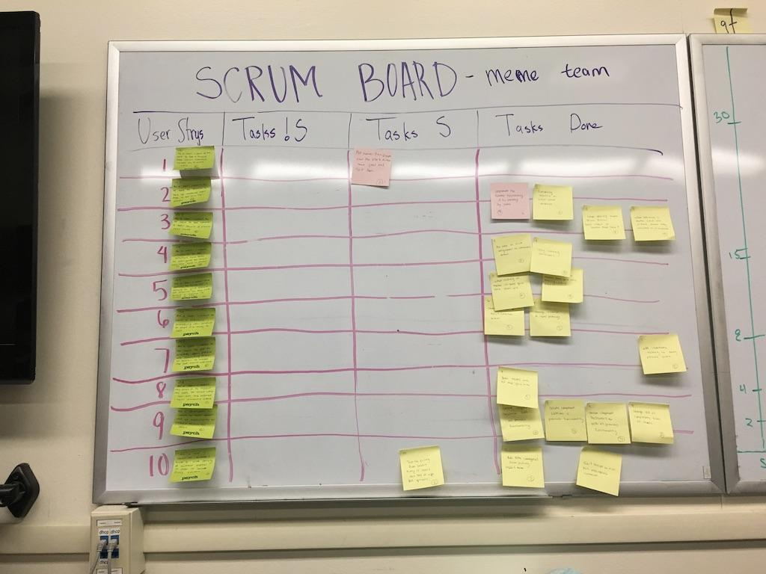

**Final Burn Up Chart:**

